

SOFTWARE APPLICATIONS: APPLICATIONS DEVELOPMENT

Activity: Mapping a Simple Entity

Transform the following entities in Global Fast Foods into table definitions:

SHIFT
REGULAR MENU
PROMOTIONAL MENU
FREQUENT DINER CARD

These are called simple entities because they are on the one side of a 1:M relationship.

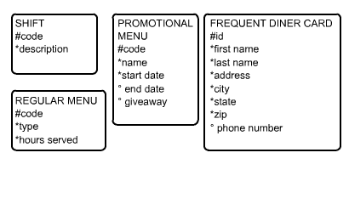

Use as many rows as necessary in the following table diagram. Use the templates overleaf.

At this point TABLES are not being created – TABLE DEFINITIONS are being created.

HTML DB will be used later to create the tables.

Write in the table name here - TABLE NAME (short name)
Key Type (pk, fk) | Optionality (“*” or “o”) | Column Name

TABLE 1

Shift_table
Key Type (pk, fk) | Optionality (“*” or “o”) | Column Name
PK | * | Code
 | * | Description

TABLE 2

Reg_menus
Key Type (pk, fk) | Optionality (“*” or “o”) | Column Name
PK | * | Code
 | * | Type
 | * | Hours_served

TABLE 3

promo_menus
Key Type (pk, fk) | Optionality (“*” or “o”) | Column Name
Pk | * | Code
 | * | Name
 | * | Start_Date
 | O | End_Date
 | O | Giveaway

TABLE 4

Freq_diner_cards
Key Type (pk, fk) | Optionality (“*” or “o”) | Column Name
PK | * | Id
 | * | First_Name
 | * | Last_Name
 | * | Address
 | * | City
 | * | State
 | * | Zip
 | O | Phone_Number

